Social engagement and ostensiveness: an eye tracking study

In this experiment, we used the fact that pupil size is correlated with emotional arousal to measure social engagement. Participants were shown videos of a person giving a cup. The videos varied on three parameters: the recipient of the cup (cup given towards the camera, or towards another unseen recipient), the ostensiveness of the gesture (i.e. with eye contact and facial expressiveness, or without), and the gender of the giver (male/female). We hypothesize that high ostensiveness, directedness towards the viewer, and gender heterogeneity all are positively correlated with social engagement (measured through pupil size).

# Data collection, Participants and Preprocessing

Data collected at COBE lab at Aarhus University during the course of one day, with natural differences in lighting.

Pupil size and eye position was recorded using a head-mounted Eye link 1000 monocular eye tracker, tracking the right eye with a sampling rate of 1000 Hz. The stimulus presentation script and the eye-tracking software were run separately on two different computers.  
There were six participants, four female and two male, all screened before the experiment. There was an automatic nine-point calibration, with a threshold of 1° for the average error and 1.5° for the maximum error.

Eye tracking data was automatically pre-processed and artefacts were removed using the in-built DataViewer software. Eye-blinks, saccades and fixations were identified. Data was downsampled to every tnenth data point. Data was visually expected for artefacts before analysis. A mistaken inversion of y-coordinates for the gaze positions was corrected.

# Data analysis

Four linear mixed effect models were used, listed in order of decreasing complexity below:

$$m1: S_{pupil}=β_{0p}+β_{1p}D+β_{2p}O+β_{3}T+β_{4}T^{2}+β_{5}T^{3}+ε$$

$$m2: S_{pupil}=S_{pupil}=β_{0p}+β_{1p}D+β_{2p}O+β_{3}T+β_{4}T^{2}+ε$$

$$m3: S_{pupil}=β_{0p}+β_{1p}D+β_{2p}O+β_{3}T+ε$$

$$m4: S_{pupil}=β_{0p}+β_{1p}D+β_{2p}O+ε$$

Where $S_{pupil}$ denotes the pupil size, D the direction, O the ostensivenes, T the time that has passed within the trial, $ε$ the error term and p the presence of a random component by participant.  
A cubic trend in the trial time was used because of the anticipated drop in pupil size due to the luminosity change between the between-trial screen and the stimuli and the expected deceleration in pupil size growth as the trial progressed. The trial time was scaled by dividing by 1000.

Model selection was done through 3-fold cross validation. Cross-validation was stratified at the participant level and balanced across conditions. We used out-of-sample error, operationalized as root mean square error, as selection criterion.  
All analysis was done in R.

# Results

Results of the cross validations of the models can be seen below. Since the difference in model performance is negligible, we chose model the simplest model (model 4)

|  |  |  |
| --- | --- | --- |
| Model | Mean $RMSE_{test}$ | SD of $RMSE_{test}$ |
| m1 | 1999.523 | 324.8702 |
| m2 | 1999.523 | 324.8702 |
| m3 | 1999.523 | 324.8708 |
| m4 | 1999.524 | 324.8713 |

Random effects by participant for model 4:

|  |  |
| --- | --- |
| Parameter | SD |
| Intercept | 62.167 |
| Direction | 14.320 |
| Ostensiveness | 7.362 |

Fixed effect parameters for model 4:

|  |  |  |  |
| --- | --- | --- | --- |
| Parameter | Estimate | SE | P-value |
| Intercept | 7.55 | 0.14 | P < 0.05 |
| Direction | -0.03 | 0.03 | P > 0.05 |
| Ostensiveness | -0.03 | 0.02 | P > 0.05 |

There is no significant effect of either direction or ostensiveness.

This is also reflected in the plotted data below (Pupil size as function of time. Color denotes ostensiveness, while line type denotes direction):

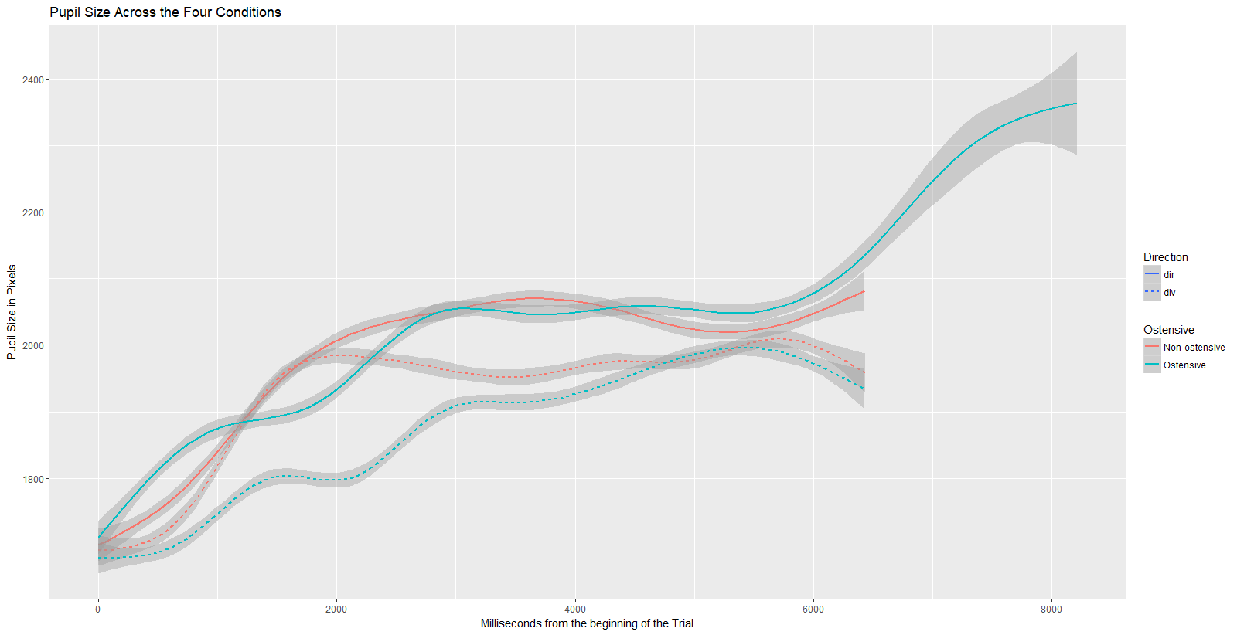

There are small differences, but no clear pattern can be seen.

Fixation duration in visual search: an eye tracking study

This study aims to investigate if visual search strategies change under different tasks and depending on the visual stimuli. Heavy tailed distributions of fixation durations are often found in visual search paradigms. This possibly stems from the foraging behavior, with few intense fixations after the rare, long saccades, and many short fixations in between. We will investigate how the stimuli and task affects this. In one task, participants were instructed to count as many as possible of similar objects in the picture. In another task, the participants were instructed to find a very small star, hidden in the picture. There were 10 trials 30 seconds long of each task, using different picture stimuli.

# Data collection, Participants and Preprocessing

Data collected at COBE lab at Aarhus University during the course of one day, with natural differences in lighting.

Pupil size and eye position was recorded using a head-mounted Eye link 1000 monocular eye tracker, tracking the right eye with a sampling rate of 1000 Hz. The stimulus presentation script and the eye-tracking software were run separately on two different computers.  
There were six participants, four female and two male, all screened before the experiment. There was an automatic nine-point calibration, with a threshold of 1° for the average error and 1.5° for the maximum error.

Eye tracking data was automatically pre-processed and artefacts were removed using the in-built DataViewer software. Eye-blinks, saccades and fixations were identified. Data was downsampled to every tnenth data point. Data was visually expected for artefacts before analysis. A mistaken inversion of y-coordinates for the gaze positions was corrected.

# Data analysis

Three linear mixed effect models were used, listed in order of decreasing complexity below:

$$m1: D_{fix}=β_{0p}+β_{1p}C+β_{2}T+β_{3p}CT+ε$$

$$m2: D_{fix}=β_{0p}+β_{1p}C+β_{2}T+ε$$

$$m3: D_{fix}=β_{0p}+β_{1p}C+ε$$

Where $D_{fix}$ denotes the logarithmic duration of the fixation, C the condition, T the trial and, $ε$ the error term and p the presence of a random component by participant. The logarithm of the fixation duration was used, to account for the expected long tailed distribution.  
Long tailed distribution of fixation durations seen here:  
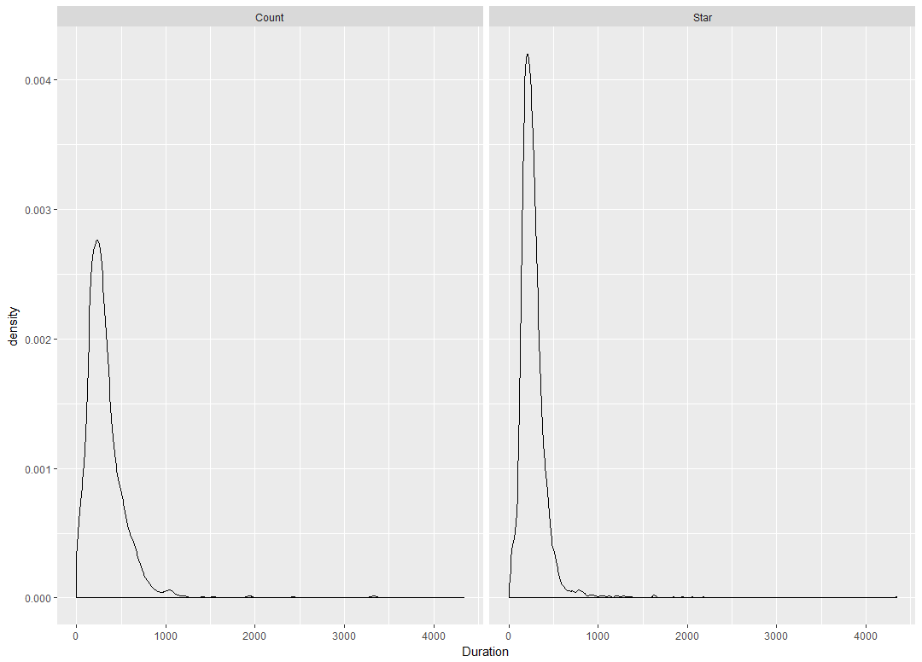

Model selection was done through 3-fold cross validation. Cross-validation was stratified at the participant level and balanced across conditions. We used out-of-sample error, operationalized as root mean square error as selection criterion.

# Results

Results of the cross-validation:

|  |  |  |  |
| --- | --- | --- | --- |
| Model | Mean $RMSE_{test}$ | Mean $RMSE_{test}-RMSE_{train}$ | SD of $RMSE_{test}$ |
| m1 | 339.5230 | 4.829480 | 30.65992 |
| m2 | 339.5183 | 4.830034 | 30.66169 |
| m3 | 339.6172 | 4.818654 | 30.62653 |

M3 has a slightly higher RMSE on the test sample, but is slightly more stable across testing and training. But generally, the differences in RMSE of the models are negligible. Thus we chose model 3, since it is the simpler model.

Random effects for model 3 by participant:

|  |  |
| --- | --- |
| Parameter | SD |
| Intercept | 45.76 |
| Condition | 30.83 |

Logarithms of fixed effects for model 3:

|  |  |  |  |
| --- | --- | --- | --- |
| Parameter | Estimate | SE | P-value |
| Intercept | 5.71 | 0.12 | P < .05 |
| Condition | -0.18 | 0.09 | P > .05 |

Below is shown the predicted fixation durations for each fixation, plotted against the observed data. Lines symbolize predicted durations, and the dots are observed values. Each colour represents a participant.

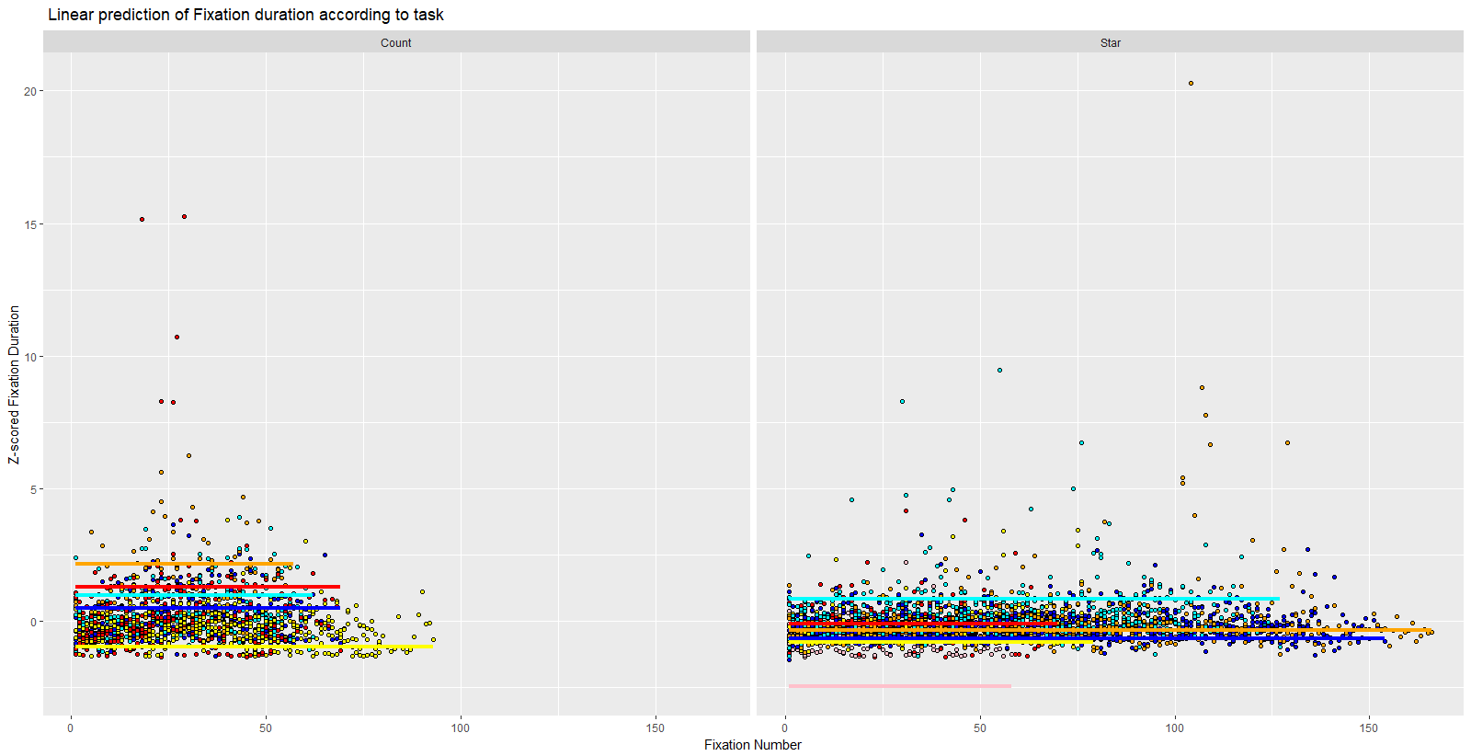

And a boxplot showing fixation durations in the two conditions. There is no clear difference between the two conditions. Based on this experiment, it is not possible conclude anything about the hypothesis.

